# **Low Level Design**

# **Investment Analytics**

|  |  |
| --- | --- |
| Written by | AMIT KUMAR |
| Document version | 1.0 |
| Last revision date | 27TH AUGUST 2021 |

# **Contents**

1. Introduction........................................................................................................................ 03

1.1 What is Low-Level Design Document? .............................................................. 03

1.2 Scope ..................................................................................................................... 03

2. Architecture ....................................................................................................................... 04

3. Architecture Description ................................................................................................ 06

3.1 Data Description ................................................................................................... 06

3.2 Web Scrapping ...................................................................................................... 07

3.3 Data Transformation .......................................................................................... 07

3.4 Data insertion into database .............................................................................. 08

3.5 Connection with Power bi desktop............................................................................... 08

3.5 Export Data from database ................................................................................. 11

3.6 Deployment ......................................................................................................... 13

# **1. Introduction**

# **1.1 What is Low-Level design document?**

The goal of the LDD or Low-level design document (LLDD) is to give the internal logic design of the

actual program code for the House Price Prediction dashboard. LDD describes the class diagrams

with the methods and relations between classes and programs specs. It describes the modules so

that the programmer can directly code the program from the document.

# **1.2 Scope**

Low-level design (LLD) is a component-level design process that follows a step-by-step refinement

process. The process can be used for designing data structures, required software architecture,

source code and ultimately, performance algorithms. Overall, the data organization may be

defined during requirement analysis and then refined during data design work.

# **2. Architecture**

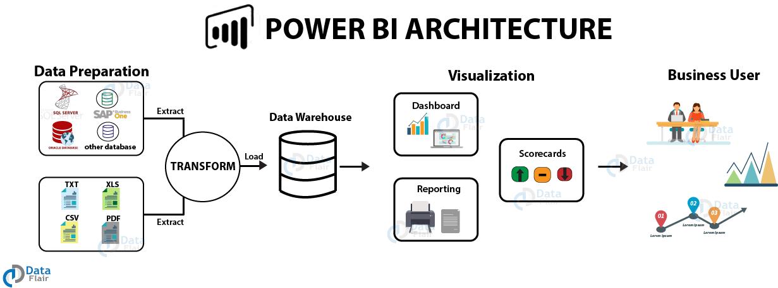

# **Power BI Architecture**

Power BI architecture is a service built on top of Azure. There are multiple data sources that Power BI can connect to. Power BI Desktop allows you to create reports and data visualizations on the dataset. Power BI gateway is connected to on-premise data sources to get continuous data for reporting and analytics. Power BI services refer to the cloud services that are used to publish Power BI reports and data visualizations. Using Power BI mobile apps, you can stay connected to their data from anywhere. Power BI apps are available for Windows, IOS, and Android platforms.

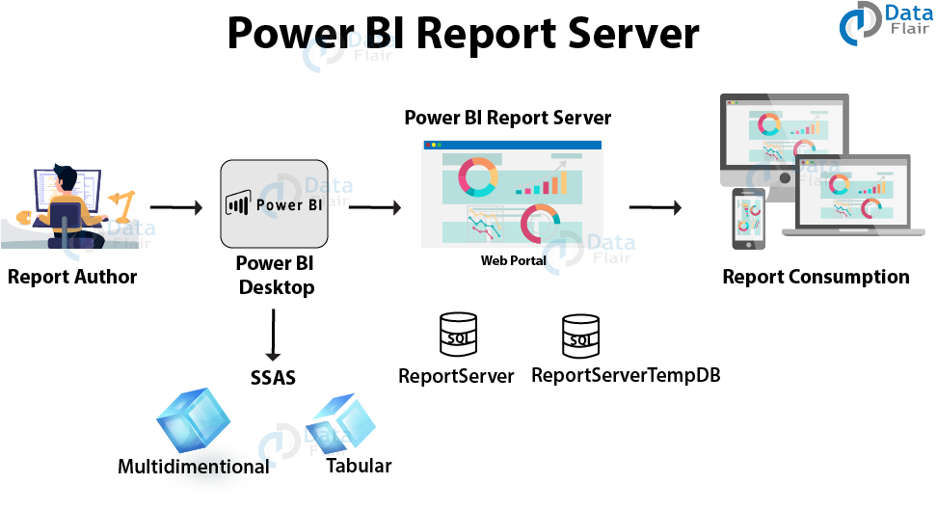

Power BI Report Server is an on-premises report server with a web portal in which you display and manage reports and KPIs. Along with it come the tools to create Power BI reports, paginated reports, mobile reports, and KPIs. Your users can access those reports in different ways: viewing them in a web browser or mobile device, or as an email in their in-box.

# **3. Architecture Description**

# **3.1. Data Description**

Investment is a game of understanding historic data of investment objects under

different events but it is still a game of chances to minimize the risk we apply analytics

to find the equilibrium investment.

To understand the Foreign direct investment in India for the last 17 years from 2000-01

to 2016-17. This dataset contains sector and financial year-wise data of FDI in India

Data is provided in csv format.

# **Content**

# **Data Information:**

1. Sector
2. Fiscal Year
3. FDI Value

here, sectors consist of total 63 industry mentioned in data with FDI value starting from

financial year 2000 to 2016.

The FDI values mentioned here is in millions US dollars.

# **3.2. Web Scrapping**

Web scraping is a technique to automatically extract content and data from websites using bots.

It is also known as web data extraction or web harvesting. Web scrapping is made simple now

days, many tools are used for web scrapping. Some of python libraries used for web scrapping are

Beautiful Soup, Scrapy, Selenium, etc.

# **3.3. Data Transformation**

In the Transformation Process, we will convert our original datasets with other necessary

attributes format. And will merge it with the Scrapped dataset.

# **3.4. Data Insertion into Database**

a. Database Creation and connection - Create a database with name passed. If the database is already created, open the connection to the database.

b. Table creation in the database.

c. Insertion of files in the table

# **3.5. Connection of data source to power bi desktop**

With Power BI Desktop, you can connect to data from many different sources. We can connect to data by using the **Home** ribbon. To show the **Most Common** data types menu, select the **Get data** button label or the down arrow.

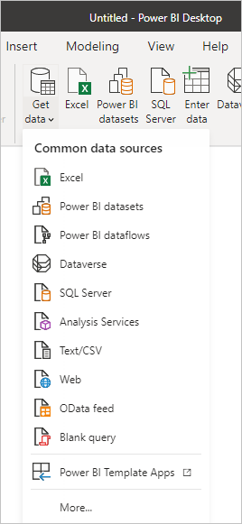

To go to the **Get Data** dialog box, show the **Most Common** data types menu and select **More**. You can also bring up the **Get Data** dialog box (and bypass the **Most Common** menu) by selecting the **Get Data** icon directly.

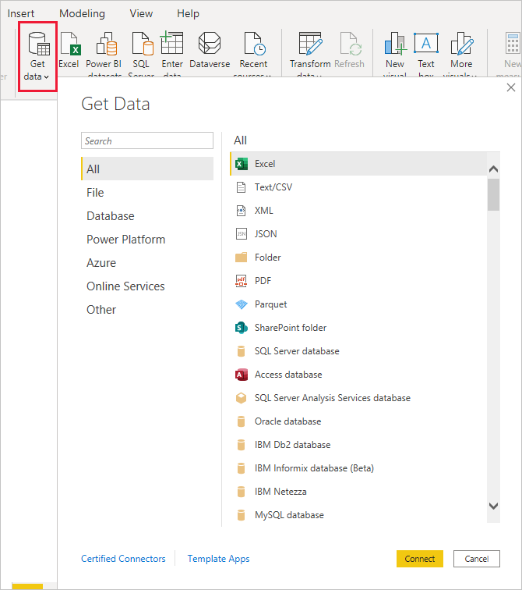

# **Data sources**

The **Get Data** dialog box organizes data types in the following categories:

* All
* File
* Database
* Power Platform
* Azure
* Online Services
* Other

The **All** category includes all data connection types from all categories.

### File data sources

The **File** category provides the following data connections:

* Excel
* Text/CSV
* XML
* JSON
* Folder
* PDF
* Parquet
* SharePoint folder

The following image shows the **Get Data** window for **File**.

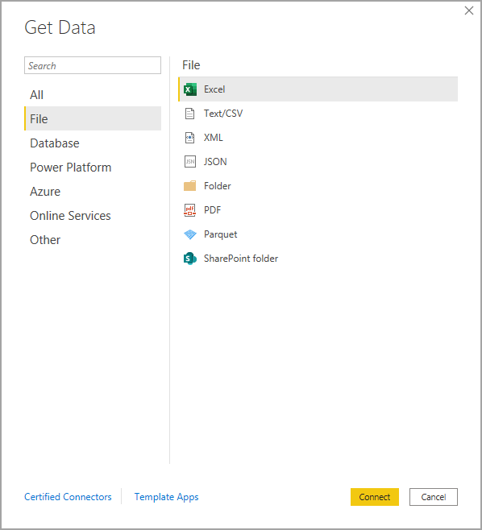

### Some of the Database data sourcesare:-

The **Database** category provides the following data connections:

* SQL Server database
* Access database
* SQL Server Analysis Services database
* Oracle database
* IBM Db2 database
* IBM Informix database (Beta)
* IBM Netezza
* MySQL database
* PostgreSQL database
* Sybase database
* Teradata database
* SAP HANA database
* SAP Business Warehouse Application Server
* Etc.

# **3.6 Export data from a Power BI dashboard**

1. Select More actions (...) from the upper-right corner of the visualization.

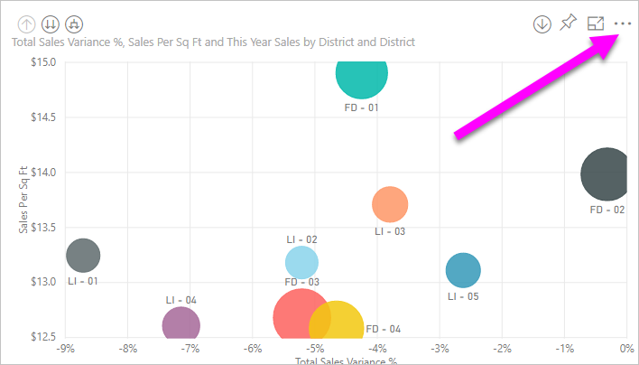

1. Choose the **Export to .csv** option.

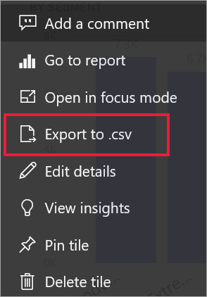

3. Power BI exports the data to a *.csv* file. If you've filtered the visualization, then the .csv export will be filtered as well.

4.Your browser will prompt you to save the file. Once saved, open the *.csv* file in Excel.

# **3.7 Deployment.**

Deployment pipelines enable creators to develop and test Power BI content in the Power BI service, before the content is consumed by users. The content types include reports, paginated reports, dashboards, and datasets. The tool is designed as a pipeline with three stages: Development.

# **Deployment process**

In Power BI Desktop, choose File > **Publish** > Publish to Power BI or select Publish on the ribbon. Sign in to Power BI, if you aren't already signed in. Select the destination. You can search your list of available workspaces to find the workspace into which you want to publish.

# **Publish datasets and reports from Power BI Desktop**

When you publish a Power BI Desktop file to the Power BI service, you publish the data in the model to your Power BI workspace. The same is true for any reports you created in **Report**view. You’ll see a new dataset with the same name, and any reports in your Workspace navigator.

Publishing from Power BI Desktop has the same effect as using **Get Data** in Power BI to connect to and upload a Power BI Desktop file.

# **To publish a Power BI Desktop dataset and reports**

1. In Power BI Desktop, choose **File** > **Publish** > **Publish to Power BI** or select **Publish** on the ribbon.

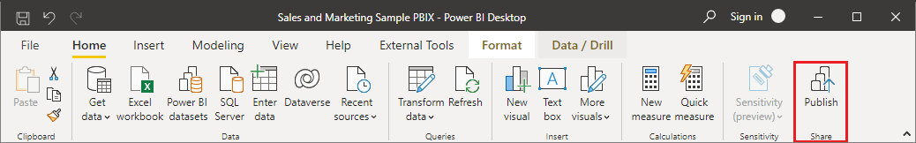

2.Sign in to Power BI, if you aren't already signed in.

3.Select the destination. You can search your list of available workspaces to find the workspace into which you want to publish. The search box lets you filter your workspaces. Select the workspace, and then click the **Select** button to publish.

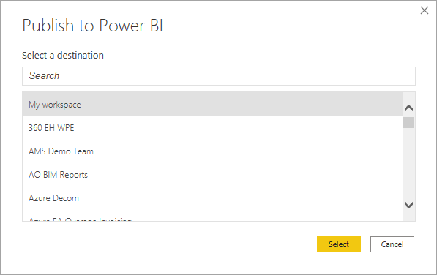

When publishing is complete, you receive a link to your report. Select the link to open the report in your Power BI site.